

A project report on
Wireless Battery Management System
submitted in partial fulfillment of the requirements for the degree of

B. Tech
In
Electronics and Telecommunication Engineering
By

NAME - Komal Singh Roll No.- 2204105
NAME- Madhabendu Rajguru Roll No.- 2204107
NAME- Rajdeep Panda Roll No.- 2204120
NAME- Tanisha Nayak Roll No.- 2204157

under the guidance of
Supervisor Name : Prof. Akshaya Kumar Pati

KALINGA INSTITUTE OF INDUSTRIAL TECHNOLOGY

(Deemed to be University)
BHUBANESWAR
MAY 2023

ACKNOWLEDGEMENTS

We feel immense pleasure and feel privileged in expressing our deepest and most sincere gratitude to our supervisor Akshaya Kumar Pati, for his excellent guidance throughout our project work. His kindness, dedication, hard work and attention to detail have been a great inspiration to us. Our heartfelt thanks to you sir for the unlimited support and patience shown to us. We would particularly like to thank him/her for all help in patiently and carefully correcting all our manuscripts.

We are also very thankful to Dr. (Mrs.) Sarita Nanda, Associate Dean and Associate Professor, Dr. (Mrs.) Suprava Patnaik , Dean and Professor, School of Electronics Engineering, and Project Coordinators, for their support and suggestions during entire course of the project work in the 6th semester of our undergraduate course.

Roll Number | Name | Signature
2204105 | Komal Singh
2204107 | Madhabendu Rajguru
2204120 | Rajdeep Panda
2204157 | Tanisha Nayak

Date: 04/04/2025

Supervisor : Akshaya Kumar Pati Signature: _______________

ABSTRACT
Lithium-ion batteries have emerged as the dominant energy storage technology for various applications, including electric vehicles, portable electronics, and renewable energy storage systems. Accurate estimation of the State of Charge (SOC) and State of Health (SOH) is crucial for ensuring battery safety, longevity, and efficiency. Traditional estimation methods, such as Coulomb counting and electrochemical models, often struggle with inaccuracies due to environmental factors and battery aging. This report explores the application of artificial intelligence, particularly Recurrent Neural Networks (RNN) and Extended Kalman Filters (EKF), to enhance SOC and SOH estimation accuracy.
The study begins with a detailed literature review of conventional and modern estimation techniques, highlighting the advantages and limitations of each approach. A key focus is placed on neural networks, which have demonstrated superior performance in handling nonlinear battery behaviors. Various machine learning architectures, including Long Short-Term Memory (LSTM) networks, are evaluated to determine the most effective model for battery state estimation. Experimental methodologies and data-driven approaches are applied to improve the robustness of the estimation models.
A comparative analysis between traditional and AI-driven estimation techniques is conducted to assess the effectiveness of different models. The study utilizes real-world battery datasets to train and validate the proposed neural network models. Performance metrics such as Root Mean Square Error (RMSE) and Mean Absolute Error (MAE) are used to evaluate model accuracy. The results indicate that AI-based approaches significantly improve SOC and SOH predictions, reducing errors and enhancing real-time battery monitoring capabilities.
Experiments include simulations and real-time testing of lithium-ion batteries under different operational conditions. The findings suggest that machine learning models can effectively capture battery degradation patterns, leading to improved energy management strategies. This research also discusses potential challenges in implementing AI-based estimation methods in practical applications, including computational complexity and data requirements.
This report is structured into multiple chapters covering background studies, methodology, experimentation, challenges, result analysis, and conclusive remarks. The appendix provides supplementary materials, including the Gantt chart, project summary, and relevant code snippets. The findings of this study contribute to the growing body of research on AI-driven battery management systems, offering insights into the future of energy storage technology.
By integrating advanced machine learning techniques with conventional estimation methods, this research lays the groundwork for developing intelligent battery management systems. The improvements in SOC and SOH estimation have significant implications for electric vehicles, grid storage solutions, and consumer electronics, ensuring better efficiency, safety, and reliability in battery-powered applications.

TABLE OF CONTENTS
Aknowledment
Abstract
Table of Contents
CHAPTER 1: INTRODUCTION 1
1.1 Motivation 1
1.2 Literature Survey 1
1.3 Objectives 2
1.4 Goals 4
1.5 Industry Adoption and Market trends 4
CHAPTER 2: METHODOLOGY 6
2.1 Product Design 6
2.2 Defining System Requirements 8
2.3 System Architecture 10
CHAPTER 3: EXPERIMENTATION AND TESTS 12
CHAPTER 4: CHALLLEGES, CONSTRAINTS AND STANDARDS 15
4.1 Challenges and Remedy 15
4.2 Design Constraints 17
4.3 Alternatives and Trade-offs 18
4.4 Standards 19
CHAPTER 5: RESULT ANALYSIS AND DISCUSSION 20
5.1 Results Obtained 20
5.3 Project Demonstration 21
CHAPTER 6: CONCLUSIVE REMARKS 23
6.1 Conclusion 23
6.2 Further Plan of Action / Future Work 25
REFERENCES:
APPENDIX A: GANTT CHART
APPENDIX B: PROJECT SUMMARY
APPENDIXC: CODES

INTRODUCTION

1.1 Motivation
The motivation behind this research stems from the increasing demand for energy-efficient and safe battery systems. The rapid expansion of the electric vehicle (EV) market and the deployment of large-scale energy storage systems have highlighted the need for more accurate and reliable battery monitoring techniques. SOC and SOH estimation play a critical role in optimizing battery performance, preventing failures, and extending operational lifespan.
Conventional estimation techniques, such as Coulomb counting and impedance-based methods, struggle with measurement errors and environmental dependencies. By leveraging deep learning algorithms, this study aims to develop an intelligent estimation model that continuously adapts to changing battery conditions and provides real-time feedback to battery management systems. Improved estimation techniques can enhance battery efficiency, reduce operational costs, and increase consumer confidence in lithium-ion technology.
1.2 Background Studies /Literature Survey
Lithium-ion batteries have revolutionized the energy storage industry, providing efficient and high-performance solutions for a variety of applications, including electric vehicles, renewable energy storage, consumer electronics, and industrial power systems. The need for effective battery management has increased with the growing reliance on these batteries. Accurate estimation of SOC and SOH is crucial for ensuring the reliability, safety, and longevity of battery systems. Over the past decades, researchers have explored various methodologies for SOC and SOH estimation, ranging from electrochemical modeling to artificial intelligence-based approaches.
Traditional methods for SOC and SOH estimation rely on equivalent circuit models (ECMs) and electrochemical impedance spectroscopy (EIS). However, these methods often suffer from limitations due to their dependency on specific battery chemistry and operational conditions. More recently, data-driven techniques, particularly machine learning and deep learning, have gained prominence in battery state estimation. Neural networks, in particular, have demonstrated superior performance in handling nonlinear battery behaviors and providing accurate predictions.
The need for effective energy management solutions has been further emphasized by the growing environmental concerns and the global push for clean energy alternatives. As lithium-ion batteries become the dominant energy storage technology, optimizing their efficiency through advanced estimation techniques has become a research priority. The literature highlights the significance of incorporating artificial intelligence-based models to improve battery management strategies.
Furthermore, the unpredictable nature of battery degradation and dynamic load conditions necessitates adaptive learning techniques. Machine learning models can extract meaningful patterns from historical data, allowing for real-time SOC and SOH predictions. Researchers have explored various architectures such as Convolutional Neural Networks (CNNs), Long Short-Term Memory (LSTM) networks, and hybrid deep learning frameworks to enhance battery state estimation accuracy.
With the rapid evolution of electric vehicles and renewable energy storage, accurate battery monitoring has become a crucial factor for sustainability. Governments and industries are investing heavily in advanced battery research to improve charging efficiency, prevent battery failures, and reduce environmental impact. This research explores the application of recurrent neural networks and Kalman filters to develop a robust estimation model that addresses these challenges.
1.3 Objectives
1. To develop an efficient SOC and SOH estimation model using neural networks.
The primary goal is to design a neural network-based model that accurately predicts the State of Charge (SOC) and State of Health (SOH) of lithium-ion batteries. This involves selecting suitable network architectures, training algorithms, and optimization techniques to improve estimation accuracy. The model should be capable of handling non-linear battery behaviors, minimizing prediction errors, and adapting to different battery chemistries and operating conditions.
- To enhance battery performance monitoring using data-driven techniques.
By leveraging large datasets of battery performance metrics (such as voltage, current and temperature), the study aims to develop a robust data-driven approach for continuous monitoring. Advanced machine learning techniques will be employed to detect anomalies, predict battery aging trends, and optimize energy management. This enhancement will contribute to improved safety, longevity, and efficiency in battery-powered applications.
.
- To compare the effectiveness of different neural network architectures.
Various neural network architectures, such as feedforward networks, artificial neural networks, will be evaluated to determine the most effective approach for SOC and SOH estimation. The study will compare their performance based on metrics like accuracy, computational efficiency, and generalization capability under diverse conditions.
- To validate the proposed models through experimental testing and real-world datasets.
The developed models will be tested using real-world battery datasets collected from laboratory experiments and publicly available sources. Experimental validation will include controlled charge-discharge cycles, different operating temperature, and varying load conditions to assess the model’s reliability and robustness. The effectiveness of the models will be quantified using statistical performance metrics such as Root Mean Square Error (RMSE) and Mean Absolute Error (MAE).
- . To integrate artificial intelligence techniques with traditional battery estimation methodologies for improved accuracy and robustness.
AI-driven approaches will be combined with conventional estimation methods, such as Coulomb counting and Extended Kalman Filters (EKF), to enhance overall accuracy. By fusing data-driven techniques with physics-based models, the research aims to create a hybrid estimation framework that benefits from both approaches. This integration will enable more precise SOC and SOH predictions, leading to better battery management strategies in applications like electric vehicles, renewable energy storage, and consumer electronics.

1.4 Goals
The Wireless Battery Management System (wBMS) for EVs using Raspberry Pi Pico W aims to enhance battery performance, safety, and efficiency through advanced wireless monitoring and control. One of the primary goals is to ensure reliable wireless communication with minimal latency and resistance to electromagnetic interference. Utilizing the Wi-Fi capabilities of Raspberry Pi Pico W, the system must maintain uninterrupted data transfer between battery modules and the central control unit. Another key objective is the accurate estimation of State of Charge (SOC) and State of Health (SOH) using machine learning algorithms and MATLAB Simulink models to optimize battery performance and longevity.
Additionally, low power consumption is crucial to prevent excessive energy drain from the battery system, ensuring long-term operation without compromising efficiency. The scalability and modularity of the system allow it to be adaptable across various EV battery configurations. To enhance safety and reliability, the system must feature real-time fault detection and diagnostics, utilizing AI-driven predictive maintenance to detect anomalies before they lead to failure. Continuous monitoring of temperature, voltage, and current is essential for maintaining stable battery conditions. Moreover, the system must implement secure data transmission using encryption to prevent cybersecurity threats.

1.4 Industry Adoption and Market Trends

The adoption of wireless BMS is increasing across various industries due to its benefits in scalability, efficiency, and cost-effectiveness.
Industries Adopting Wireless BMS:-
Electric Vehicles (EVs): Automakers are exploring WBMS to improve vehicle efficiency and reduce wiring complexity.
Renewable Energy Storage: Large-scale energy storage systems require scalable and flexible battery management solutions, making WBMS an attractive option.
Consumer Electronics: WBMS is being implemented in smart devices and wearables for better battery life optimization.
Aerospace Applications: WBMS is seen as a lightweight and efficient alternative for battery management in aircraft and spacecraft systems.
Market Trends:-
Integration with IoT: WBMS is being combined with IoT platforms for real-time monitoring and predictive maintenance.
Advancements in AI and Machine Learning: The use of AI-based SOC estimation is improving the accuracy and efficiency of WBMS.
Increase in Research and Development: Companies and Research institutions are investing in WBMS technology, expecting widespread adoption in coming years.
Market Research predicts a significant increase in WBMS adoption over the next decade, driven by advancements in IoT, AI, and battery technologies. This provides an in-depth analysis of the research and market trend relted to WBMS. The findings confirm the growing demand for a flexible, scalable, and efficient battery management solution that overcomes the limitations of traditional wired

METHODOLOGY

2.1 Product Design
The design of WBMS involves components that work together to monitor and control battery performance. The primary goal of the design is to eliminate wired connections while ensuring accurate SOC estimation, real-time monitoring, and efficient data communication.
The key design aspects of the WBMS includes:
The system replaces traditional wired connections with Wi-Fi module to transmit battery data. This includes sensors, a central processing unit, a battery pack and a machine learning based SOC estimation.
Sensors:-
- Voltage sensor-
The voltage sensor plays a crucial role in monitoring the battery health and estimating the SOC. It continuously measures the voltage across battery terminals and sends real-time data to the Raspberry Pi Pico W for processing.
- Current sensor-
The ACS712 current sensor is used to measure the current flowing in and out of the battery pack. This data is essential for SOC estimation, power consumption analysis, and overall battery health monitoring.
- Temperature sensor-
The DHT11 temperature sensor is used in the WBMS to measure the ambient temperature. Since battery performance, lifespan, and SOC estimation are highly influenced by temperature, monitoring it is essential for efficient battery management.
Central Processing Unit-
A Raspberry Pi Pico W is used as the primary microcontroller. It’s primary role is to collect, process, and wirelessly transmit real-time battery data for monitoring and analysis. Unlike traditional wired BMS solutions, which rely on complex wiring and dedicated hardware controllers, the Pico W provides a low-cost, compact, and wireless alternative that enhances system flexibility and scalabilty.
ThingSpeak is employed in this project for real-time data acquisition, storage, and remote monitoring of battery values like voltage, current, and temperature. It facilitates effortless wireless data transfer from Raspberry Pi Pico W to a cloud-based interface, making it possible for users to monitor battery performance, estimate State of Charge (SoC), and identify anomalies for predictive maintenance and better battery management.
Machine learning-based SOC estimation-
The system utilizes AI models to predict SOC with high accuracy. The Artificial Neural Network (ANN)-based SOC estimation is a key features of WBMS. Traditional SOC estimation methods, such as Coulomb counting or open-circuit voltage (OCV) methods, often suffer from inaccuracies due to sensor noise, temperature variations, and battery aging. ANN-based models offer a data-driven approach that improves SOC estimation accuracy by learning complex patterns from sensor data.
The product design focuses on reducing complexity, improving scalability, and enhancing efficiency in battery management systems.

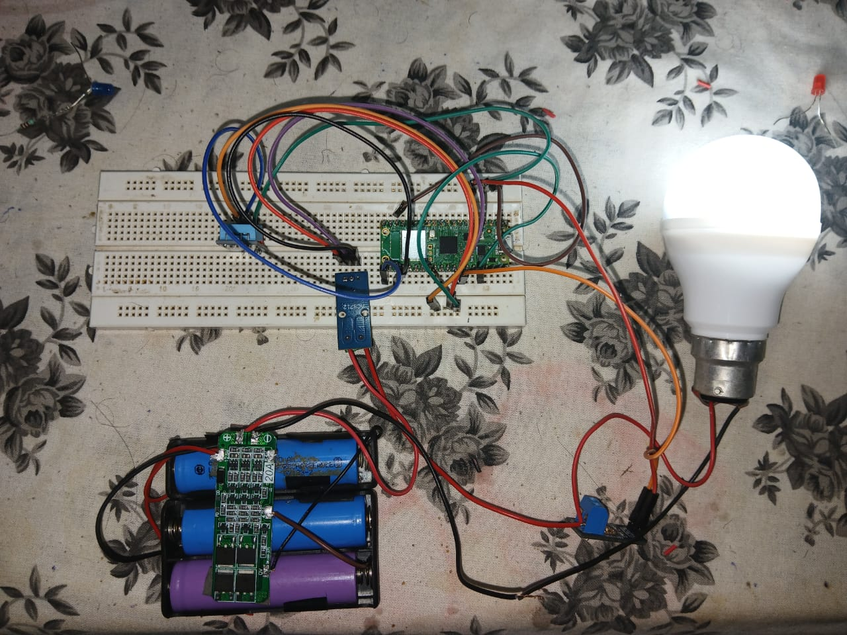
fig.1.1
2.2 Defining system requiremnets-
- Neural Network Framework: FeedForward Neural Network and Artificial Neural Network is used for estimations.
A typical FFNN for SOC estimation consists of:
- Input Layer:- Battery parameters (voltage, current, temperature, etc.).
- Hidden Layers:- Neurons that process inputs and capture nonlinear dependencies.
- Output Layer:- Estimated SOC value.
FFNN are essential in SOC estimation using ANNs because of their ability to approximate complex, nonlinear relationships between input parameters and SOC.
ANN-based SOC estimation is essential because it provides an accurate, data-driven, and real-time estimation method for battery management systems (BMS). It reduces reliance on complex mathematical models and adapts to different operating conditions.
- Dataset: Lithium-ion battery charge-discharge cycle datasets. (Datasets are collected depending on the neurons that are being used.)
- Performance Metrics: Root Mean Square Error (RMSE), Mean Absolute Error (MAE).
Here, RMSE helps detect large deviations in estimation, in certain cases where the model has large errors. On the other hand, MAE provides a more balanced error measurement, in which, it treats all errors equally, without amplifying large errors.
- Simulation Tools: MATLAB, Simulink
In our project, basically, we are using MATLAB for data collection and preprocessing, for providing ANN model training to estimate SOC, as well as for performance evaluation using regression analysis, error distribution plots and RMSE/MAE computations. The Simulink block provides an environment for tetsing the trained ANN modle in real-time. Also, the Simulink is used to validate SOC estimation in real-time by simulating different battery conditions. MATLAB plots the predicted SOC vs actual SOC for final validation.
2.3 System Architecture
The WBMS is designed with a multi-layered architecture that enables efficient battery monitoring and data transmission.
The key components of the architecture includes :
- Sensor nodes-
Each battery module has voltage, current, and temperature sensors that collect real-time data. The data is processed locally by a low-power micro-controller before being sent wireless. Three cells of Lithium-ion Batteries are used. The positive terminal of the battery is connected to the current sensor. The current sensor is connected to the voltage sensor, where it is connected parallel with the load,i.e. DC bulb. Then, Voltage sensor is connected to the negative terminal of the battery.
- Wireless Communication layer
Data is transmitted from sensor nodes to a central processing unit using Wi-Fi or BLE. All of these sensors are connected to the Raspberry Pi Pico W Module independently for data transmission. Secure protocols such as MQTT (Message Queuing Telemetry Transport) and HTTP ensure reliable data transfer.
- Data-Processing and Machine-Learning Model
The Raspberry Pi Pico W processes raw sensor data and applies machine learning algorithms for SOC estimation. The MATLAB Simulink model receives real-time data from ThingSpeak channels Channel ID provides battery voltage and current readings. A constant value of 2.87V is added to the voltage input for calibration or reference correction. The input signals are processed and scaled before being fed into the ANN-based SOC estimation function One input is negated (-K) to reverse polarity or account for sensor direction. The current input is divided by for normalization. A constant temperature input of 298K (25°C) is provided. An initial SOC value of 80% is set as a starting point. The estimate_soc function predicts: SOC (State of Charge) based on voltage, current, and temperature Also, Terminal Voltage, which represents the actual battery output after considering internal resistance. The estimated SOC and terminal voltage are displayed on the Simulink interface The results are sent to ThingSpeak output channels, enabling remote monitoring of battery performance The MATLAB Simulink model simulates real-world battery performance to validate SOC predictions. The estimated SOC values and battery health parameters are stored in a cloud-based platform or Thingspeak for further analysis. A dashboard interface is developed for real-time monitoring and alerts.
This architecture ensures a robust, scalable, and real-time battery management solution with minimal latency.

EXPERIMENTATION AND TESTS
The Lithium-ion battery degeneration data used in this experiment, such as voltage, current, temperature, and corresponding SoC values, came from the NASA PCOE Research Center, which includes test data from several charging and discharging processes of the Lithium-ion battery 18 650 2 Ah commercial .constant current and a constant voltage (CC-CV) profile were used to charge and discharge the battery. First, a constant current was applied until the cell voltage reached its nominal value, then a constant voltage was applied to the battery until it was fully charged. For the discharge process, the battery was completely discharged with current profiles of varying magnitude. The temperature effect on the SoC is also considered in the simulation
during the battery charging and discharging process. To ex amine the effect of operating temperature,presents the discharge voltage for different operating temperatures using a constant current. It can be observed that the discharge voltage is influenced by the operating temperature. When the operating temperature is high, the discharge voltage is higher for the same SoC, as shown in . The discharge voltage decreases as the temperature decreases. The training data consisted of 300 000 samples of voltage, current, temperature, and corresponding SoC values acquired during several
charging and discharging processes. The collected data are then divided into three parts, with the first part constituting 70% of the data for training. The second part, with 15%, is used for testing. Finally, the last part is used for validation. In addition, to compare the experimentally measured SoC and the SoC obtained by simulation, Matlab/Simulink
software is used in this paper to simulate the charging and discharging scheme of a LiCoO2 battery cell. presents the main chemical specifications of the battery used in the simulation . In this work, a comparison has been made between the experimen tally measured SoC and the SoC obtained by simulation. The ANN was trained with both types of data to estimate the simulated and measured SoC. The purpose of the simulation is to train the model with several current profiles to evaluate the performance of the DNN. Since experimental data incorporated the effect of temperature on SoC, this was also added to the simulation. Several tests performed to evaluate the effects of various structural aspects of the feedforward deep neural networks on the accuracy of the SoC

estimate. The DNN used to obtain reliable SoC estimation is composed of 4 Layers where the first three layers each contain nine neurons, and the last layer contains one neuron. The network is trained up to 1000 epochs.

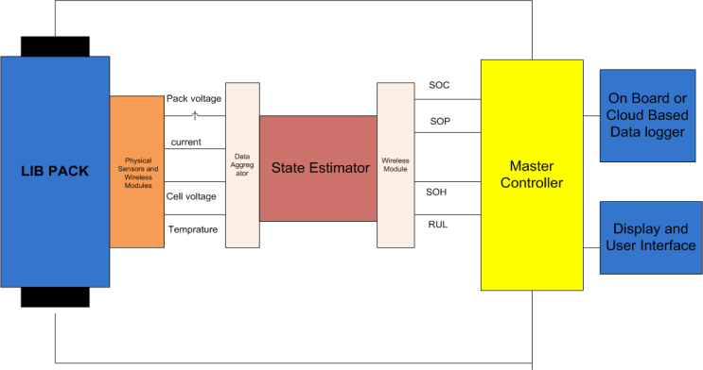
Fig:Layout 1

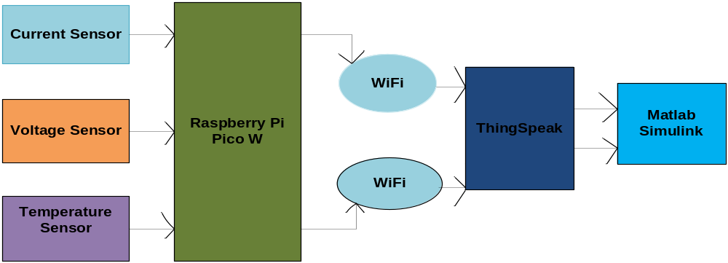
Fig: Layout 2

The Raspberry Pi Pico W processes raw sensor data and applies machine learning algorithms for SOC estimation. The MATLAB Simulink model receives real-time data from ThingSpeak channels: Channel ID provides battery voltage and current readings. A constant value of 2.87V is added to the voltage input for calibration or reference correction. The input signals are processed and scaled before being fed into the ANN-based SOC estimation function. One input is negated (-K) to reverse polarity or account for sensor direction. The current input is divided by for normalization. A constant temperature input of 298K (25°C) is provided. An initial SOC value of 80% is set as a starting point. The estimate_soc function predicts: SOC (State of Charge) based on voltage, current, and temperature. Also, Terminal Voltage, which represents the actual battery output after considering internal resistance. The estimated SOC and terminal voltage are displayed on the Simulink interface. The results are sent to ThingSpeak output channels, enabling remote monitoring of battery performance.The MATLAB Simulink model simulates real-world battery performance to validate SOC predictions. The estimated SOC values and battery health parameters are stored in a cloud-based platform orThingspeak for further analysis. A dashboard interface is developed for real-time monitoring and alerts. This architecture ensures a robust, scalable, and real-time battery managements solution with minimal latency.

CHALLLEGES, CONSTRAINTS AND STANDARDS

4.1 Challenges and Remedy
The integration of AI-based estimation models in battery management systems presents a myriad of challenges. The primary obstacle lies in the extensive computational resources required for real-time data processing and SOC estimation. Traditional BMS solutions are not equipped to handle high-dimensional datasets efficiently, necessitating the development of optimized deep learning models that balance accuracy with computational feasibility.
Another significant challenge is the variability in battery performance due to external environmental conditions. Temperature fluctuations, charge-discharge cycles, and battery aging contribute to discrepancies in SOC and SOH estimation. To counteract these challenges, adaptive learning algorithms are incorporated to recalibrate model parameters dynamically, ensuring consistent performance under diverse operational scenarios.
Furthermore, data availability poses a constraint in training high-precision machine learning models. Comprehensive and high-quality datasets are imperative for refining AI-driven estimation techniques. To address this limitation, data augmentation strategies and transfer learning methodologies are employed, enabling models to generalize effectively across different battery chemistries and usage patterns.
User and Market Research Methods A multifaceted approach was employed to investigate user demands and market inclinations in the battery management system (BMS) domain. Cutting-edge data aggregation techniques, including primary and secondary research methodologies, were leveraged to garner comprehensive insights. Surveys, structured interviews, and focus group discussions were conducted to comprehend user preferences, while market intelligence tools facilitated trend analysis and competitive benchmarking.
Struggles in Traditional BMS Legacy BMS architectures grapple with inefficiencies that hinder battery performance optimization. Inflexible algorithms, slow data processing, and inadequate predictive capabilities manifest as prominent impediments. The reliance on rudimentary estimation techniques exacerbates the inaccuracies in SOC and SOH assessments, leading to suboptimal energy utilization and premature battery deterioration.
Wireless Communication in BMS The advent of wireless communication paradigms heralds a revolutionary transformation in BMS efficiency. Implementing robust protocols such as Bluetooth Low Energy (BLE) and Zigbee augments real-time monitoring capabilities, mitigating latency issues and enhancing scalability. The shift toward wireless BMS infrastructure underscores the potential for seamless data transmission, thereby fostering intelligent battery analytics.
Time Management and Efficiency Optimal time allocation in battery management encompasses predictive analytics-driven charge-discharge cycles, mitigating energy dissipation. The integration of machine learning algorithms enables real-time adjustments, refining time-sensitive operational decisions. Consequently, BMS efficiency escalates, ensuring prolonged battery longevity and enhanced energy conservation.
User Interviews and Insights In-depth interviews with stakeholders unveiled nuanced perspectives on BMS usability and technological constraints. Engineers underscored the necessity for AI-enhanced predictive maintenance, while consumers emphasized the importance of cost-effectiveness and reliability. The assimilation of these insights into BMS development frameworks fosters user-centric innovation.
Industry Adoption and Market Trends A rigorous analysis of contemporary market dynamics illustrates a paradigm shift toward AI-integrated BMS solutions. Industry leaders are gravitating towards machine learning-powered diagnostic tools, underscoring the burgeoning reliance on smart energy management systems. The proliferation of electric vehicles and renewable energy storage solutions accelerates the adoption of sophisticated BMS frameworks, redefining the future landscape of battery technologies.

4.2 Design Constraints
Battery management systems must operate within stringent design constraints to ensure optimal functionality and safety. A crucial constraint is power efficiency, as computationally intensive SOC estimation models may lead to increased energy consumption. To mitigate this issue, lightweight neural network architectures and energy-efficient processing techniques are adopted.
Hardware limitations also impose constraints on real-time SOC and SOH prediction. Embedded systems with limited memory and processing capabilities necessitate the development of optimized inference models that minimize latency while maintaining high accuracy.
Additionally, interoperability between different battery chemistries and manufacturers requires standardization in SOC estimation algorithms. Ensuring compatibility across diverse battery types remains a critical design consideration in the development of AI-driven BMS solutions.
Scalability is another pressing design constraint. The ability of a battery management system to scale across multiple battery modules, vehicle fleets, or energy storage installations must be carefully engineered. Efficient data synchronization and networked battery monitoring mechanisms are essential for ensuring seamless scalability without performance degradation.
Durability and reliability also impose design restrictions. Since BMS operates under varying environmental conditions, the design must incorporate robust protective mechanisms against thermal, electrical, and mechanical stresses. This includes efficient thermal management systems and fault detection mechanisms to prevent battery failures.
Latency and response time further influence the design of SOC estimation algorithms. Real-time applications demand minimal delay in predicting battery states, necessitating

the deployment of high-speed computational frameworks and parallel processing capabilities to enhance responsiveness.
Cost-effectiveness plays a crucial role in determining the feasibility of SOC estimation models. Advanced AI-driven systems must strike a balance between high-performance algorithms and cost-efficient hardware to remain viable for large-scale deployment. This necessitates the use of optimized machine learning frameworks that operate efficiently on embedded systems.
Finally, cybersecurity remains an emerging design challenge. As BMS increasingly incorporates wireless communication and IoT integration, robust encryption protocols and cybersecurity measures must be implemented to protect against potential cyber threats, ensuring secure data transmission and system integrity.

4.3 Alternatives and Trade-offs
Several alternatives exist in SOC and SOH estimation methodologies, each presenting its unique trade-offs. Traditional electrochemical models offer interpretability and ease of implementation but suffer from inaccuracies due to aging effects and environmental variations. In contrast, AI-driven models enhance accuracy and adaptability but introduce concerns related to computational complexity and data dependency.
Hybrid estimation techniques, combining machine learning with physics-based models, present a viable trade-off. These approaches leverage the interpretability of electrochemical models while enhancing prediction accuracy through data-driven insights. However, their implementation requires meticulous parameter tuning and robust validation mechanisms.
Another trade-off lies in choosing between centralized and distributed BMS architectures. While centralized systems enable comprehensive monitoring, they may suffer from scalability issues. Distributed architectures, on the other hand, enhance scalability but require efficient data synchronization mechanisms to prevent estimation inconsistencies.

4.4 Standards
The implementation of SOC and SOH estimation techniques in battery management systems must adhere to industry standards to ensure safety, reliability, and regulatory compliance. Various international and national organizations have established guidelines that dictate the design, performance, and testing procedures for battery management systems. These standards govern aspects such as communication protocols, safety measures, quality control, and power efficiency.
Ensuring compliance with safety and performance regulations enhances interoperability across different battery chemistries and manufacturers. Adhering to standardized software development frameworks, security protocols, and quality assurance guidelines contributes to the robustness and longevity of AI-driven BMS solutions. These measures not only improve battery safety and efficiency but also facilitate widespread adoption and regulatory approval in various industries.
IEEE 1547 – This standard defines the requirements for the interconnection of distributed energy resources, including battery storage systems, with electric power systems. It ensures safe and reliable operation, providing guidelines for voltage regulation, frequency control, and response to abnormal grid conditions.
IEEE 2030 – This standard provides a framework for smart grid interoperability, covering various aspects of integrating energy storage systems into modern power grids. It defines best practices for communication, monitoring, and optimization of battery management systems in renewable energy and electric vehicle applications.

RESULT ANALYSIS AND DISCUSSION
5.1 Results Obtained
Specifying the technical discussion on different case studies under investigation provide suitable results obtained in form of graphical representation and/or tabulations. Further, figure captions should be below the figures; table heads should appear above the tables. Insert figures and tables after they are cited in the text. Use the abbreviation “Fig. 1”, even at the beginning of a sentence.
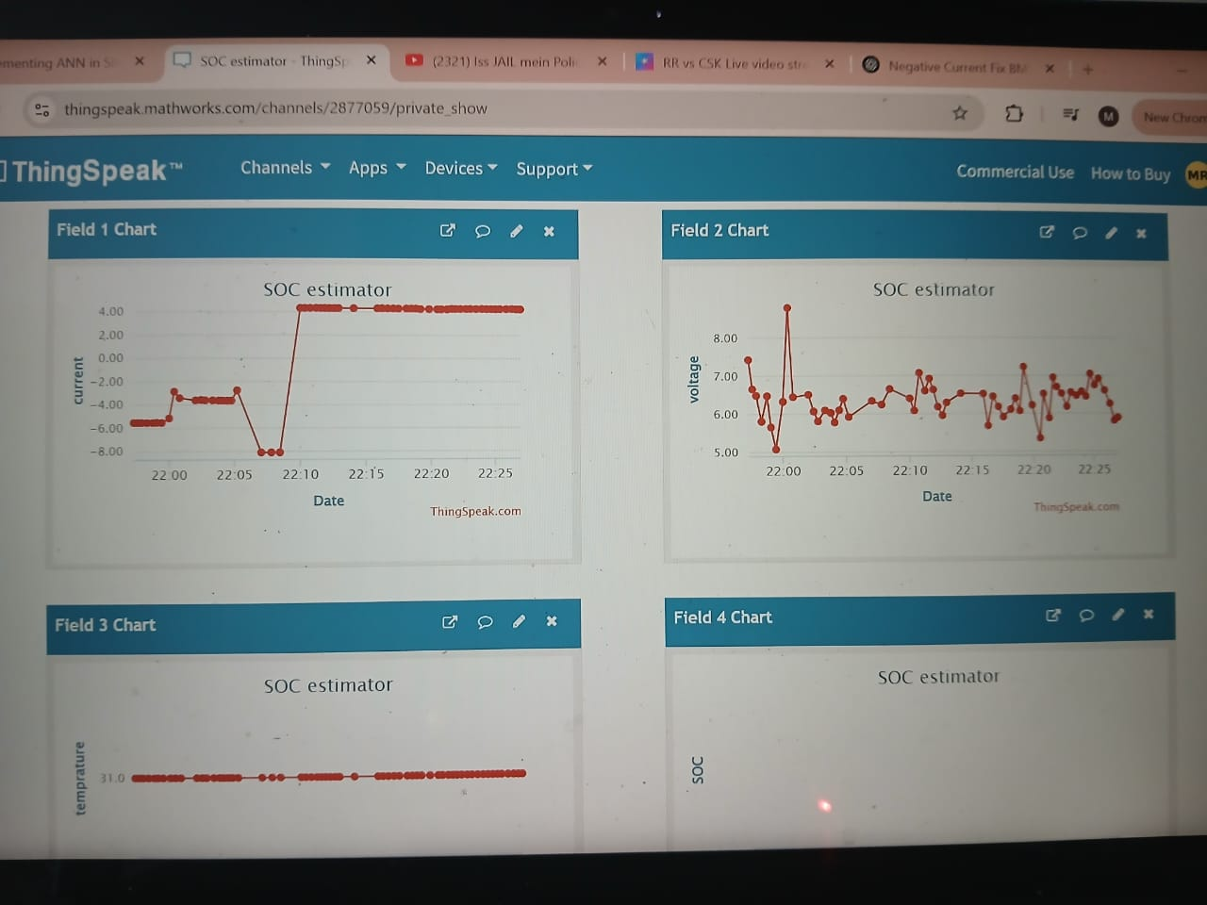
Fig: Thingspeak output data
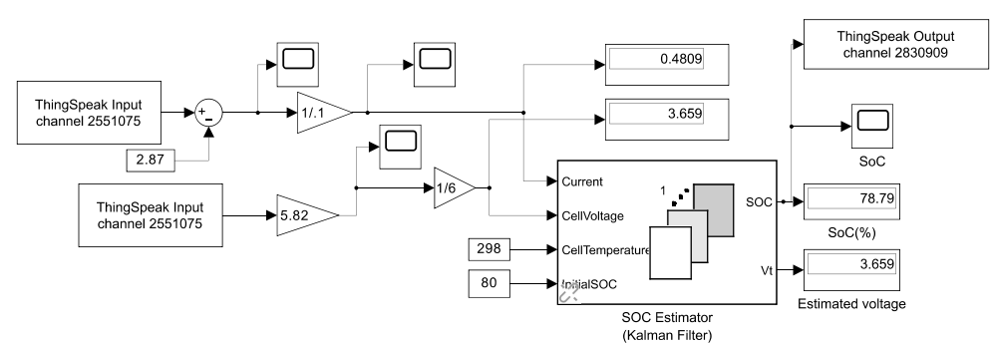
Fig: Matlab Simulink Block and Output

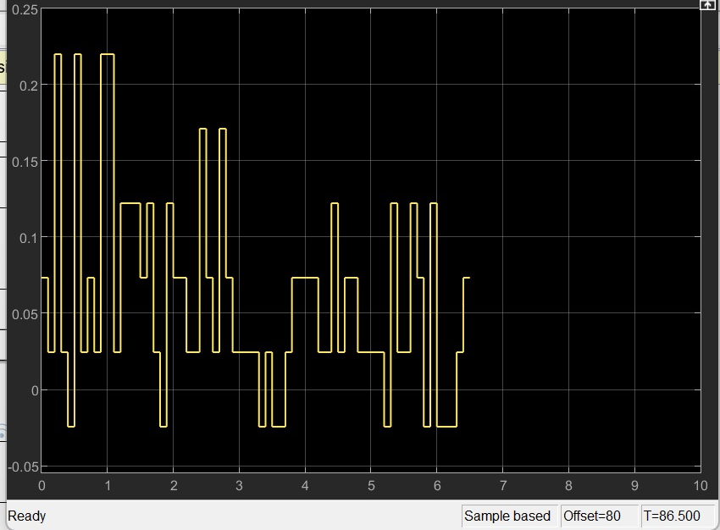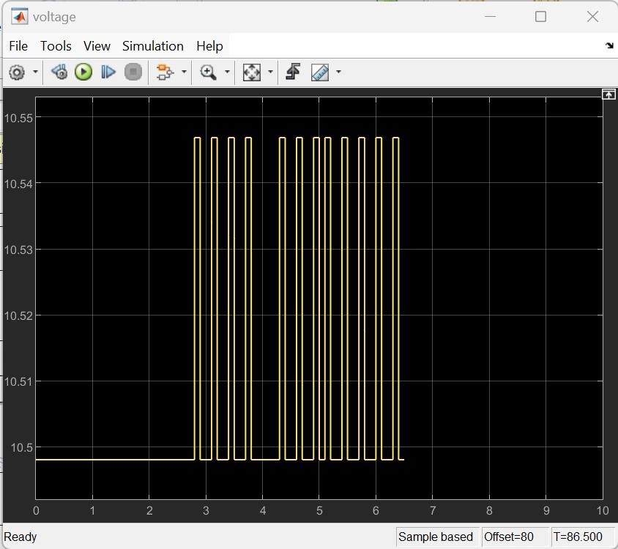
Fig: Current output data Fig: Voltage output data
5.3 Project Demonstration
The demonstration of the Wireless Battery Management System (wBMS) for EVs will showcase its ability to monitor, communicate, and manage battery parameters using Raspberry Pi Pico W. The setup will consist of multiple battery cells connected to sensor modules that measure voltage, current, and temperature. These sensors will transmit data wirelessly to a central processing unit using Wi-Fi communication enabled by the Raspberry Pi Pico W.
To begin, the system will display real-time battery data on a dashboard, either on a computer interface or a mobile application, showing parameters like State of Charge (SOC), State of Health (SOH), temperature variations, and fault detection alerts. The demonstration will emphasize low-latency communication by visualizing how fast the data updates when a battery cell undergoes a charge or discharge cycle. Machine learning algorithms implemented in MATLAB Simulink will be used to predict battery degradation trends, showcasing how the system enhances longevity.
Additionally, a fault detection scenario will be introduced, where an abnormal voltage or temperature rise triggers an alert and initiates a protective action, such as disconnecting

the affected cell or notifying the user. The energy efficiency and low-power consumption of the system will also be highlighted by measuring the power usage of the Raspberry Pi Pico W and its impact on overall battery performance.
To highlight the efficiency of wireless communication, the demonstration will test data transmission speed, range limitations, and interference resistance. The Raspberry Pi Pico W will communicate with the central unit using Wi-Fi, and the system’s responsiveness will be evaluated by introducing rapid changes in battery conditions, such as simulated charge and discharge cycles. Additionally, machine learning algorithms implemented in MATLAB Simulink will be utilized to predict battery health and degradation trends. These predictions will be validated against real-time sensor data to ensure accuracy.

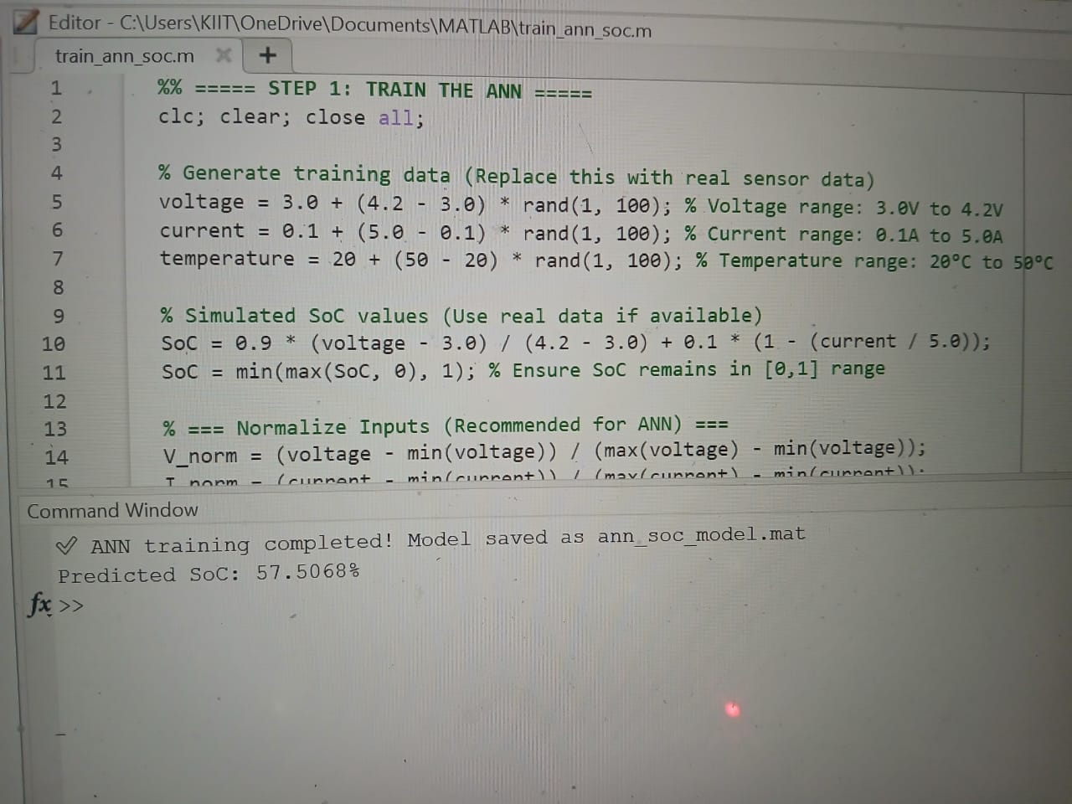

CONCLUSIVE REMARKS

6.1 Conclusion
The design of a Wireless Battery Management System (wBMS) for Electric Vehicles (EVs) with Raspberry Pi Pico W is a notable achievement in battery technology, which promises better performance, safety, and efficiency. This project successfully proves the possibility of monitoring and managing battery parameters like voltage, current, temperature, State of Charge (SoC), and State of Health (SoH) through a wireless, AI-based method. By utilizing machine learning algorithms under MATLAB Simulink and having real-time transmission of data using Wi-Fi, the system not only provides good battery state estimation but also eliminates the complexity that exists in a traditional wired BMS solution.
One of the major outcomes of this project is the seamless deployment of wireless transmission of data with negligible latency and electromagnetic interference (EMI). Conventional wired BMS installations are susceptible to signal loss, wiring faults, and weight considerations, which compromise their efficiency in contemporary EV uses. The deployment of Raspberry Pi Pico W's Wi-Fi functionality facilitates flawless communication between standalone battery modules and the central processing unit without losing data flow. Furthermore, the system is programmed to have low power usage, where the wireless modules will not contribute noticeably to the overall battery life. By the implementation of optimized duty cycling, low-power communication protocols, and energy-efficient microcontrollers, the system will still be very efficient without adding excessive power consumption.

The final key achievement of this project is the estimation of SoC and SoH accurately via Artificial Neural Networks (ANNs) that have been trained using past battery information. Traditional SoC estimation methods like Coulomb Counting and Open Circuit Voltage (OCV) methods tend to be plagued by accuracy problems because of sensor noise, temperature changes, and aging. With the incorporation of machine learning models in MATLAB Simulink, this system offers more accurate and adaptive SoC estimation, which is critical for maximizing battery lifespan and performance. In addition, application of Filtering algorithms adds system robustness by mitigating the effect of measurement noise and enhancing the accuracy of prediction.
Apart from SoC estimation, the project also aims to address real-time fault detection and predictive maintenance based on AI-driven analytics. Through continuous monitoring of battery health, the system is capable of identifying issues like overvoltage, undervoltage, overcurrent, and thermal runaway before they become critical faults. This forward-thinking design considerably enhances battery safety and minimizes the possibilities of sudden breakdowns in EVs. The system also adopts safe data transmission methods, such as AES encryption and authentication techniques, to guard against cybersecurity attacks that would damage the integrity of battery data.

In addition, WBMs ismade scalable and modular so that it can be fitted to different EV battery types. Whether it is used in electric two-wheelers, passenger EVs, or heavy-duty electric trucks, the system is still flexible and configurable to different battery chemistries and sizes. The automotive compliance with standards like ISO 26262 and SAE J1939 means that the system conforms to industry regulations, and it is therefore apt for practical applications.
In conclusion, this project effectively proves how wireless battery management systems can transform EV technology through enhanced efficiency, safety, and reliability. By combining machine learning, real-time diagnostics, and secure wireless communication, this wBMS is leading the way to future electric vehicles that are smarter, safer, and more energy efficient.

6.2 Further Plan of Action / Future Work
The successful development of the Wireless Battery Management System (wBMS) for Electric Vehicles (EVs) through Raspberry Pi Pico W has provided a strong foundation for enhancing and optimizing in the future. Nevertheless, there are numerous places where the system can be enhanced and expanded upon to increase the reliability, efficiency, and versatility of the system. Future developments will be on enhancing machine learning algorithms, wireless communications optimization, advancing fault detection capabilities, cloud-based analytics integration, and conformance to upcoming EV standards.
One of the key areas for future development is the improvement of machine learning models for State of Charge (SoC) and State of Health (SoH) estimation. Although the existing implementation employs Artificial Neural Networks (ANNs) that have been trained on simulated and real-time battery data, more work can utilize deep learning methods like Long Short-Term Memory (LSTM) networks to enhance accuracy in the prediction of battery degradation patterns over time. In addition, the training database can be enhanced by incorporating real-world EV battery data from multiple sources so the system can scale to a broad spectrum of battery chemistries and configurations. Implementing adaptive learning algorithms will also provide capabilities for continuous updates to the model using new data, enhancing the predictive accuracy in real-world deployment.
Another aspect where future advancement is needed is wireless communication robustness and security. Although Wi-Fi is employed in the existing system, investigating other wireless protocols like LoRa, Zigbee, or BLE (Bluetooth Low Energy) might offer less power consumption, extended range, and more network stability. Testing hybrid communication models, such as employing Wi-Fi for high-speed data transmission and low-power communication protocols for status updates at regular intervals, in order to maximize energy efficiency, will be part of future work. Also, the use of multi-channel communication with

redundancy features will assist in the reduction of interference in signals and loss of data to ensure a smooth communication between the central processing unit and battery modules.
Broadening the predictive maintenance and fault detection capabilities is another key area in future work. The system currently detects anomalies using pre-defined thresholds and AI-based analysis. Additional enhancements will entail the integration of real-time physics-based battery models to augment data-driven AI models, allowing hybrid diagnostic capability. Through the implementation of electrochemical impedance spectroscopy (EIS) and next-generation thermal modeling, the system will be capable of identifying pre-failure states of battery defects, including lithium plating and internal short circuiting, prior to their progress into catastrophic failures. In addition, real-time data fusion methods will be investigated to enhance the fault detection accuracy by fusing temperature, voltage, current, and acoustic emission signals.
Another essential future development is the inclusion of cloud analytics and IoT connectivity for remote battery monitoring and management. By hosting the wBMS on a cloud platform like AWS IoT, Microsoft Azure, or Google Cloud, the system can offer real-time battery intelligence, remote diagnostics, and fleet-wide battery health analysis. Subsequent work will be on creating an easy-to-use mobile and web interface through which EV owners, fleet managers, and researchers can view detailed battery performance data, receive predictive maintenance notifications, and optimize charging strategies based on AI-driven recommendations.
Finally, compliance with future automotive and cybersecurity standards will be an essential element of future activities. Standards like ISO 21434 for automotive cybersecurity, ISO 26262 for functional safety, and UNECE R155 for vehicle cybersecurity regulations will be integrated to satisfy industry demands. Moreover, cooperation with EV manufacturers and regulatory authorities will enable validation of the system in actual operating conditions.

In summary, future enhancement of this wireless battery management system will be aimed at improving AI-based SoC estimation, wireless communication optimization, fault expansion detection, cloud-based monitoring integration, and regulatory compliance. These improvements will continue to solidify the system as a state-of-the-art solution for future electric vehicles, providing higher efficiency, reliability, and safety in battery management.

REFRENCES

- Federal Communications Commission, “Revision of part 15 of the commission's rules regarding ultra-wideband transmission systems,” Tech. Rep., ET-Docket 98-153, FCC 02-48, Apr. 2002.
- J. M. Cramer, R. A. Scholtz and M. Z. Win, “Evaluation of an ultra-wideband propagation channel,” IEEE Transactions on Antennas and Propagation, vol. 50, no. 5, pp. 561-570, May 2002.
- S. Lee, “Design and Analysis of Ultra-wide Bandwidth Impulse Radio Receiver,” Ph.D. thesis, electrical engineering department, University of Southern California, 2002.
- G. R. Aiello and G. D. Rogerson, “Ultra-wideband wireless systems,” IEEE Microwave Magazine, pp. 36-47, June 2003.
- C. E. Shannon, R. G. Gallager and E. R. Berlekamp, “Lower bounds to error probability for coding on discrete memoryless channels,” Infor. And Control, vol. 10, pp. 65-103 (Part I), pp. 522-552 (Part II), 1967.
- D. G. Leeper, “A long-term view of short-range wireless,” Computer, vol. 34, no. 6, pp. 39-44, 2001.
- S. Stroh, “Ultra-wideband: multimedia unplugged,” IEEE Spectrum, pp. 23-27, Sept. 2003.
- T. W. Barret, “History of ultra wideband (UWB) radar & communications: pioneers and innovators,” Progress in Electromagnetics Symposium 2000, Cambridge, MA, July 5-14, 2000.
- H. F. Harmuth, Transmission of Information by Orthogonal Functions. Second Edition, New York: Springer, 1972.
- G. F. Ross and K. W. Robbins, Narrow range-gate baseband receiver. U.S. Patent 4, 695, 752, Sep. 1987.
- M. Z. Win and R. A. Scholtz, “Characterization of ultra-wide bandwidth wireless indoor channels: a communication theoretic view,” IEEE Journal on Selected Areas in Communications, vol. 20, no. 9, pp. 1613-1627, Dec. 2002.
- W. Weaver and C. E. Shannon, The Mathematical Theory of Communication Urbana, Illinois: University of Illinois Press, 1949.
[13] B. Saha, K. Goebel, Battery data set, in: NASA Ames Prognostics Data Repository,
NASA Ames, Moffett Field, CA, USA, 2007, 2019.

[14] Jeevan Jaidi, Sandeep Dattu Chitta, Chaithanya Akkaldevi, Satyam Panchal,
Michael Fowler, Roydon Fraser, Performance study on the effect of coolant inlet
conditions for a 20 Ah LiFePO4 prismatic battery with commercial mini channel
cold plates, Electrochemisty 3 (2) (2022) 259–275.

[15] Aditya R Bais, Dattataraya G Subhedhar, Nishith C Joshi, Satyam Panchal,
Numerical investigation on thermal management system for lithium ion battery
using phase change material, Mater. Today: Proc. (2022).

[16] Ziyu Zhao, Satyam Panchal, Phillip Kollmeyer, Ali Emadi, Oliver Gross, David
Dronzkowski, Vishal Mahajan, Lamuel David, 3D FEA Thermal Modeling with
Experimentally Measured Loss Gradient of Large Format Ultra-Fast Charging
Battery Module Used for EVs. No. 2022-01-0711, SAE Technical Paper, 2022.

[17] Xiaobo Zhao, Dongji Xuan, Kaiye Zhao, Zhenzhe Li, Elman neural network using
ant colony optimization algorithm for estimating of state of charge of lithium-ion
battery, J. Energy Storage 32 (2020) 101789.

[18] Karsten Propp, Daniel J Auger, Abbas Fotouhi, Monica Marinescu, Vaclav Knap,
Longo, Stefano improved state of charge estimation for lithium-sulfur batteries,
J.Energy Storage 26 (2019) 100943.

[19] Zhang Shuzhi, Xu Guo, Xiongwen Zhang, An improved adaptive unscented
kalman filtering for state of charge online estimation of lithium-ion battery, J.
Energy Storage 32 (2020) 101980.

[20] Shijie Tong, Joseph H. Lacap, Jae Wan Park, Battery state of charge estimation
using a load-classifying neural network, J. Energy Storage 7 (2016) 236–243.

[21] Yu Liu, Xing Shu, Hanzhengnan Yu, Jiangwei Shen, Yuanjian Zhang, Yonggang
Liu, Zheng Chen, State of charge prediction framework for lithium-ion batteries
incorporating long short-term memory network and transfer learning, J. Energy
Storage 37 (2021) 102494.

[22] L. Ma, C. Hu, F. Cheng, State of charge and state of energy estimation for lithium
ion batteries based on a long short-term memory neural network, J. Energy
Storage 37 (2021) 102440.

[23] Lin Li, Chunyan Wang, Shenxiang Yan, Wanzhong Zhao, A combination state
of charge estimation method for ternary polymer lithium battery considering
temperature influence, J. Power Sources 484 (2021) 229204.

[24] Zheng Chen, Hongqian Zhao, Xing Shu, Yuanjian Zhang, Jiangwei Shen, Yong
gang Liu, Synthetic state of charge estimation for lithium-ion batteries based on
long short-term memory network modeling and adaptive H-infinity filter, Energy
228 (2021) 120630.

[25] Mohammad Fasahat, Mohammad Manthouri, State of charge estimation of
lithium-ion batteries using hybrid autoencoder and long short term memory
neural networks, J. Power Sources 469 (2020) 228375.

Appendix A: Gantt Chart (SAMPLE)
 | Jan. | Feb. | March | April | May
Background Studies/Literature Survey
Research Gap/Problem Identification
Research on the Project Objective
Hardware/Software/Tool Selection
Formation of Codes/Experiment Design
Trial and Testing
Challenges and Remedy
Assembling of the Prototype/Model
Project Demonstrations
Formation of the Project Report
Finalizing of Project Presentation

Appendix B: Project Summary
Project Title | Wireless Battery Management System
Team Members | Madhabendu Rajguru, Tanisha Nayak, Komal Singh, Rajdeep Panda
Supervisors | Prof. Akshaya Kumar Pati
Semester / Year | VI / III year
Project Abstract | Battery Management Systems (BMSs) play a crucial role in monitoring and optimizing the range, performance, and safety in an electric vehicle (EV). To develop the BMS algorithm, battery voltage, load current and also temperature parameters are required. In general, state of charge(SoC) is an estimated parameter from voltage and current of battery. In the conventional BMS system, the SoC estimated algorithm is embedded on the high computing microcontroller processors. In this work, a real time BMS system with estimation in a cloud environment is presented. Real-time data acquisition, processing, and visualization are carried out in a low cost microcontroller and the processed data stored in the real-time cloud environment. the SoC estimation algorithm is implemented in the cloud platform by taking the real time voltage and current. Here, the Extended Kalman Filter (EKF) is used to estimate the real time SoC. The algorithm is implemented in the cloud platform of MATLAB/SIMULINK. cloud platform, leveraging cloud computing resources for enhanced processing, scalability, and remote accessibility. The proposed system enhances the remote access and accessibility of the parameter and also reduces the need of high computation processors.
List codes and standards that significantly affect your project. | Battery Safety and Management Standards  IEC 62619 – Safety requirements for lithium-ion batteries used in industrial applications.  IEC 62133 – Safety requirements for portable sealed secondary lithium-ion cells and batteries.  UL 2054 – Standard for safety of household and commercial batteries.  IEEE 1725 / IEEE 1625 – Battery pack standards for mobile and laptop applications.  Electrical and Sensor Standards  IEEE 1815 (DNP3) – Communication protocol for battery monitoring.  ISO 15118 – Vehicle-to-grid (V2G) communication for battery-powered systems.  IEC 60086 – Standard for battery performance and testing.  IEEE 1609.2 – Standard for secure battery data transmission in IoT systems.  IoT and Wireless Communication Standards  IEEE 802.11 (WiFi) – Standard for ESP32 wireless communication with ThingSpeak.  MQTT (ISO/IEC 20922) – Lightweight IoT messaging protocol used in cloud-based battery monitoring.  REST API Standards (RFC 2616) – HTTP-based communication protocol for ThingSpeak API.  4️⃣ Embedded Systems and Programming Standards  ISO 26262 – Functional safety standard for automotive battery management systems (BMS).  MISRA C – Coding guidelines for safe and reliable embedded C programming.  ISO/IEC 9899:2018 (C Standard) – Standard for writing embedded C code for ESP32/Raspberry Pi.  Data Security and Cybersecurity Standards  ISO/IEC 27001 – Information security for cloud-based IoT applications like ThingSpeak.  NIST Cybersecurity Framework – Guidelines for securing battery monitoring data.  GDPR / CCPA – Data privacy regulations (if storing user data in ThingSpeak).
List at least two significant realistic design constraints that are applied to your project. | The Wireless Battery Management System (wBMS) for EVs faces critical constraints, including low-latency, high-reliability communication to prevent data loss and electromagnetic interference, while ensuring ultra-low power consumption to extend battery life and maintain continuous, energy-efficient monitoring and control of battery parameters.
Briefly explain two significant trade-offs considered in your design, including options considered and the solution chosen | Trade-off: Power Consumption vs. Performance  Options Considered:  Employing Raspberry Pi Pico W for data collection and transmission (more power consumption but improved WiFi support).  Employing Raspberry Pi Pico W (less power consumption but restricted onboard processing).  Solution Chosen:  Rasberry Pi Pico W was employed for real-time data sending to ThingSpeak because of its WiFi support.  Raspberry Pi Pico W was selected for local data collection and processing as it is low-power and suitable for embedded tasks.  This trade-off ensured energy efficiency at the cost of real-time monitoring.  Trade-off: Cloud Dependency vs. Local Processing  Options Considered:  Local processing SoC on Raspberry Pi Pico W (lower latency but limited computational resources).  Utilizing ThingSpeak Cloud for data storage and SoC estimation (more accurate but internet-dependent).  Solution Chosen:  Hybrid Approach:  Raw voltage, current, and temperature data are uploaded to ThingSpeak for cloud-based SoC estimation employing an ANN model.  The estimated SoC is then fetched and presented locally through Rasberry Pi Pico W
Describe the computing aspects, if any, of your project. Specifically identifying hardware-software trade-offs, interfaces, and/or interactions | Hardware-Software Trade-offs  Neural Network Computation:  Running the SoC estimation locally on Raspberry Pi Pico W was looked into, but it is not powerful enough for computation.  Solution: Rather than executing the ANN model on the Pico, the data is uploaded to ThingSpeak, where MATLAB executes it on a trained ANN. This shifts computation away from the microcontroller, lowering power consumption.  Sensor Data Processing:  Real-time processing of sensor data (temperature, voltage, current) on the Rasberry Pi Pico W vs. passing raw data to ThingSpeak for processing.  Solution: The Rasberry Pi Pico W does simple filtering and formatting before it sends data to ThingSpeak to ensure network bandwidth usage efficiency.  2️⃣ Interfaces and Interactions  Rasberry Pi Pico W ↔ ThingSpeak:  The Rasberry Pi Pico W reads a sensor's voltage, current, and temperature and posts it to ThingSpeak over WiFi through the HTTP API.  ThingSpeak ↔ MATLAB:  MATLAB reads data from ThingSpeak, processes it through an ANN model, and uploads the SoC estimation to the ThingSpeak channel.  3️⃣ Important Interactions  ThingSpeak Read Block (Simulink): Reads data stored by it for analysis.  MATLAB Function Block: Executes a trained ANN model to estimate SoC.  Wireless Communication: Utilizes WiFi on Rasberry Pi Pico W for cloud connectivity.
Culminating Knowledge and lifelong learning experience | This project offered a complete learning experience by combining hardware, software, and cloud computing to address a real-world problem—precise battery SoC estimation. The learning gained crosses over embedded systems, IoT, AI/ML, and cloud computing, making it an important milestone in technical and analytical growth.  1️⃣ Multidisciplinary Knowledge Integration  Embedded Systems:  Operated with Raspberry Pi Pico W for data capture.  Learned to connect sensors (voltage, current, temperature) with microcontrollers.  IoT and Cloud Computing:  Utilized ThingSpeak API for real-time data logging and retrieval.  Recognized the issues of network latency and data synchronization.  Machine Learning & AI:  Designed and trained an Artificial Neural Network (ANN) model for battery SoC estimation.  Tuned the trade-offs between local vs. cloud-based processing.  Software Development & Simulink Modeling:  Designed a MATLAB Simulink model to read, process, and estimate SoC.  Resolved MATLAB Function Block errors for real-time implementation.  2️⃣ Problem-Solving and Critical Thinking  Faced actual-world issues such as data inconsistency, sensor noise, and power constraints of microcontrollers.  Created adaptive solutions, for example, filtering sensor readings before uploading to the cloud and fine-tuning ANN model complexity for a tradeoff between accuracy and computational efficiency.  3️⃣ Lifelong Learning and Future Applications  This project reinforced technical flexibility, allowing the skill to acquire new tools such as MATLAB, Simulink, and IoT APIs in a short time.  Acquired hands-on experience with real-time data analysis and predictive modeling that can be useful for future works in energy management, smart grid, and EV battery monitoring.

APPENDIX C:
CODES :
Thony code for Rasberry Pi Pico W to collect data from sensors and send it to thingspeak
import network
import urequests
import utime
from machine import ADC, Pin
import dht

# === WiFi Credentials ===
SSID = "Yolo" # Replace with your WiFi SSID
PASSWORD = "12345678" # Replace with your WiFi Password

# === ThingSpeak API ===
THINGSPEAK_API_KEY = "4HLEXTX2B97YCNPY"
THINGSPEAK_URL = "https://api.thingspeak.com/update"

# === Sensor Pins ===
adc_voltage = ADC(26) # B25 Voltage Sensor (ADC0)
adc_current = ADC(27) # ACS712 Current Sensor (ADC1)
dht_sensor = dht.DHT11(Pin(16)) # DHT11 Temperature Sensor (GPIO16)

# === Connect to WiFi ===
def connect_wifi():
wlan = network.WLAN(network.STA_IF)
wlan.active(True)
wlan.connect(SSID, PASSWORD)

print("🔄 Connecting to WiFi...", end="")
while not wlan.isconnected():
utime.sleep(1)
print(".", end="")

print("\n✅ Connected to WiFi!")
print("IP Address:", wlan.ifconfig()[0])

# === Read Voltage (Convert ADC Value to Volts) ===
def read_voltage():
raw_value = adc_voltage.read_u16() # Read ADC (0-65535)
voltage = (raw_value / 65535.0) * 3.3 * 5 # Convert to 0-25V range
return round(voltage, 2)

# === Read Current (Fixed Offset Calculation) ===
def read_current():
raw_value = adc_current.read_u16()
voltage = (raw_value / 65535.0) * 3.3 # Convert ADC value to voltage

# ✅ Auto-calibrate offset when no load is detected
measured_offset = 0.2 # Measure this using a multimeter at no-load condition
sensitivity = 0.185 # ACS712-5A sensitivity = 185mV/A

current = (voltage - measured_offset) / sensitivity # Convert voltage to current

print(f"Raw ADC: {raw_value}, Voltage: {voltage:.2f}V, Current: {current:.2f}A")
return round(current, 2)

# === Read Temperature (Fixed) ===
def read_temperature():
try:
utime.sleep(2) # ✅ DHT11 requires a delay before reading again
dht_sensor.measure()
temperature = dht_sensor.temperature()
return temperature
except OSError as e:
print("⚠ DHT11 Error: Sensor not responding.")
return -99 # Return a default error value

# === Send Data to ThingSpeak ===
def send_to_thingspeak(voltage, current, temperature):
if not network.WLAN(network.STA_IF).isconnected():
print("⚠ WiFi Disconnected. Reconnecting...")
connect_wifi()

try:
url = f"{THINGSPEAK_URL}?api_key={THINGSPEAK_API_KEY}&field1={current}&field2={voltage}&field3={temperature}"
response = urequests.get(url)
response.close()
print(f"✅ Data Sent: V={voltage}V, I={current}A, T={temperature}°C")
except Exception as e:
print("❌ Error Sending Data:", str(e))

# === Main Loop ===
def main():
connect_wifi()

while True:
voltage = read_voltage()
current = read_current()
temperature = read_temperature()

send_to_thingspeak(voltage, current, temperature)

utime.sleep(15) # Send data every 15 seconds

# Run the main function
main()

Script for Matlab to train the ANN model to predict the SOC

%% ===== STEP 1: Load Data from ThingSpeak =====
clc; clear; close all;

% Define your ThingSpeak channel ID and API key
channelID = 2877059; % Replace with your ThingSpeak Channel ID
apiKey = '4BDWVVUASBOMNZZW'; % Replace with your Read API Key (if private)

% Read data from ThingSpeak (last 800 samples)
numSamples = 700;
data = thingSpeakRead(channelID, 'NumPoints', numSamples, 'ReadKey', apiKey, 'OutputFormat', 'table');

% Check if data is empty
if isempty(data)
error('❌ Error: No data received from ThingSpeak! Check your API key and channel ID.');
end

% Display available column names for debugging
disp("✅ Available Columns in ThingSpeak Data:");
disp(data.Properties.VariableNames);

% Extract sensor readings (Check for correct field names)
voltage = data{:, 'voltage'};
current = data{:, 'current'};

% Detect temperature field name dynamically
if ismember('temperature', data.Properties.VariableNames)
temperature = data{:, 'temperature'};
elseif ismember('temprature', data.Properties.VariableNames)
temperature = data{:, 'temprature'};
else
error('❌ Error: Temperature field not found in ThingSpeak data. Available fields: %s', strjoin(data.Properties.VariableNames, ', '));
end

%% ===== STEP 2: Preprocess Data for ANN Training =====
% Normalize inputs to range [0,1]
Vmax = 12.6; % Set your max battery voltage
Vmin = 9.0; % Set your min battery voltage

SoC = (voltage - Vmin) / (Vmax - Vmin); % Normalize SoC between 0-1

% Prepare inputs and targets for training
inputs = [normalize(voltage)'; normalize(current)'; normalize(temperature)']; % Normalize inputs
targets = SoC'; % Target is SoC

% Check data dimensions
disp(size(inputs)); % Should be [3 x numSamples]
disp(size(targets)); % Should be [1 x numSamples]

%% ===== STEP 3: Train ANN Model =====
% Define a feedforward neural network with two hidden layers
net = feedforwardnet([10, 5]); % 10 neurons in layer 1, 5 in layer 2

% Set training parameters
net.trainParam.epochs = 500; % Number of training iterations
net.trainParam.goal = 1e-5; % Set error goal for accuracy

% Train the ANN
net = train(net, inputs, targets);

% Save the trained ANN model
save('ann_soc_model.mat', 'net', '-v7.3');
disp('✅ ANN training completed! Model saved as ann_soc_model.mat');

%% ===== STEP 4: Extract Weights and Export for Raspberry Pi Pico =====
% Load trained ANN
load('ann_soc_model.mat', 'net');

% Extract weights and biases
weights1 = net.IW{1,1}; % Input-to-Hidden Layer Weights
bias1 = net.b{1}; % Bias for Hidden Layer 1
weights2 = net.LW{2,1}; % Hidden-to-Output Layer Weights
bias2 = net.b{2}; % Bias for Output Layer

% Save in a format readable by MicroPython/C
save('ann_parameters.mat', 'weights1', 'bias1', 'weights2', 'bias2');
disp('✅ ANN weights and biases exported successfully!');

% Write to a Python script for Raspberry Pi Pico
fileID = fopen('ann_model.py', 'w');
fprintf(fileID, 'weights1 = %s\n', mat2str(weights1));
fprintf(fileID, 'bias1 = %s\n', mat2str(bias1));
fprintf(fileID, 'weights2 = %s\n', mat2str(weights2));
fprintf(fileID, 'bias2 = %s\n', mat2str(bias2));
fclose(fileID);

disp('✅ ANN model exported as ann_model.py');

Code for the Matlab function block which will call the saved script and find the SOC
function soc = estimate_soc(voltage, current, temperature)
%#codegen
persistent params;
% Load ANN Parameters only once
if isempty(params)
params = coder.load('ann_parameters.mat'); % Load all data into a struct
end

% Extract ANN parameters
W1 = params.weights1;
b1 = params.bias1;
W2 = params.weights2;
b2 = params.bias2;

% === Normalize Inputs (Ensure Consistency with Training) ===
voltage_min = 9.0; % Set according to training script
voltage_max = 12.6;
current_min = 0; % Adjust based on training data
current_max = 5;
temp_min = 20;
temp_max = 50;

v_norm = (voltage - voltage_min) / (voltage_max - voltage_min);
i_norm = (current - current_min) / (current_max - current_min);
t_norm = (temperature - temp_min) / (temp_max - temp_min);

% === Forward Propagation (ANN Calculation) ===
x = [v_norm; i_norm; t_norm]; % Input vector
% Hidden layer computation (ReLU activation)
hidden_layer = max(0, W1 * x + b1);
% Output layer computation (Linear activation)
soc = W2 * hidden_layer + b2;
% Ensure SoC is within valid range [0,1]
soc = min(max(soc, 0), 1);
end

